Level 1- service Discovery

Level 2- fault tolerance

Level 3- microservice configuration

This covers how we can configure M/S

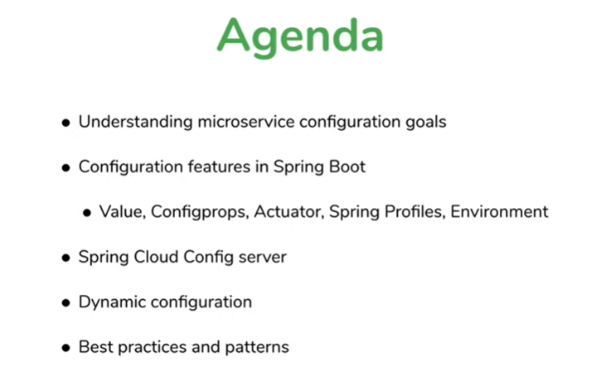

**M/S configuration what and why**



**Note:** configuration is essential for any production

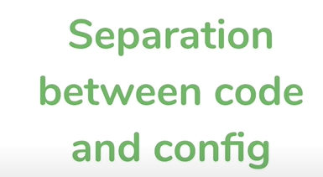



Why not hardcode

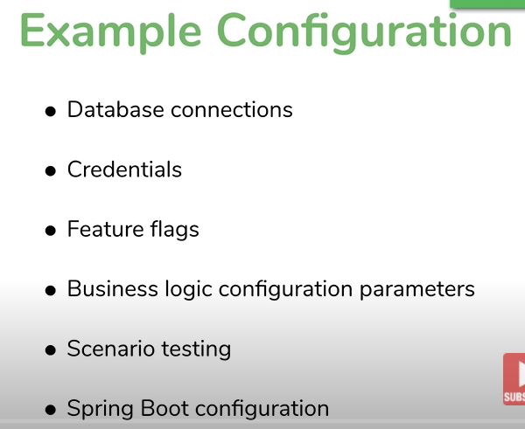

**Feature flags**

Feature Flag is a technique that enables DevOps teams to turn certain features on and off during runtime. It doesn't require redeploy new code or roll back to previous building versions. Feature Flag is also known as Feature Toggle or Feature Switch

**Scenario testing :-** like initially enabled traffic 10 %from MS1 and slowly increase it when it works fine

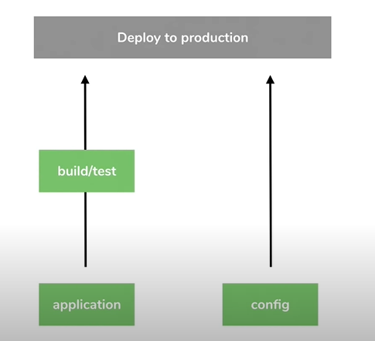

**Configs forms**

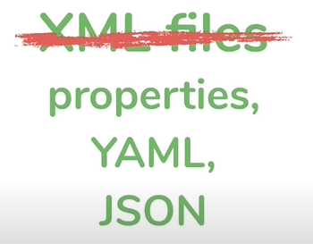

Configuration should be separate from application logic.

Configuration should be consistent across all MS

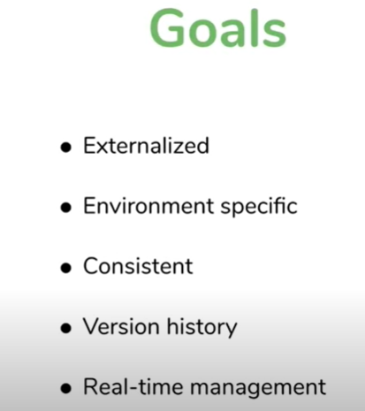

**Using property file config with spring boot**

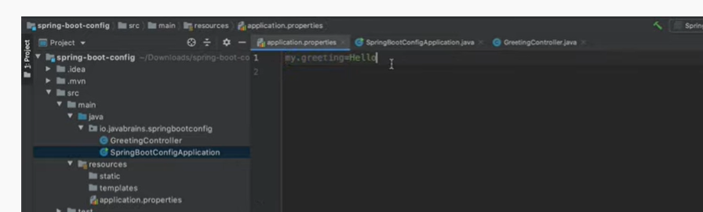

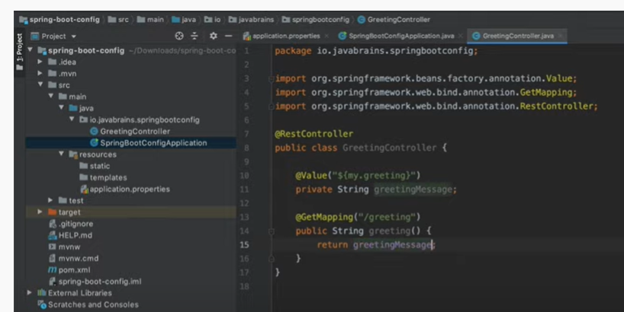

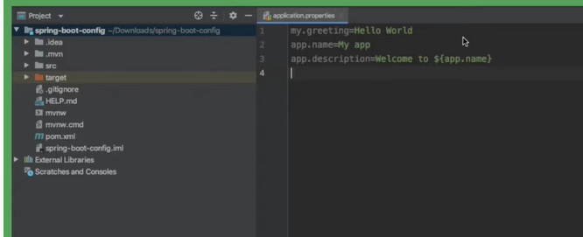

**NOTE:** when we build a application and it will create a jar and properties file sitting inside jar.

Properties file is going inside the jar what benefits we have achieved.

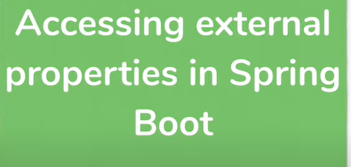

To put configuration outside the jar



Imp

![Machine generated alternative text:
tppl i cati on . properti es 
: lasses 
Ill Il 
792 
18:25 379 
18:25 : 00. 398 
18:25 :oo. 399 
18:25. 
.487 
18:25. 
.487 
18:25 :oo.978 
18:25 oo. 989 
MINGW64 /c/AFM_project/Spri nggoot/spring-boot-confi g/target 
generated-sources 
maven-archi ver spri ng-boot-confi g-O . O. I-SNAPSHOT. Jar 
generated-test-sources maven-status 
spri ng-boot-confi g-O . O . I-SNAPSHOT 
MINGW64 /c/AFM_project/Spri nggoot/spring-boot-confi g/target 
-boot-confi g-o . O . I-SNAPSHOT. jar 
. jar. original 
surefire-reports 
test-cl asses 
Java -Jar sprnng 
I xxxx 
(-1 
(V2 . 6.4) 
spring Boot . 
!022-03-13 788 
main) i . j . s . springgootconfi gApp1ication 
INFO 38696 - 
Starting springeootconfi gApp1ication VO.O.I-SNAPSHOT using Java 1.8.0_1 
NO active profile set, falling back to 1 default profile: 
" default' 
Tomcat initialized with port(s): 8080 (http) 
Starting service C Tomcat) 
Starting servlet engine: CApache Tomcat/9.O. 58) 
Initializing spring embedded webApp1icationcontext 
Root webApp1icationcontext: initialization completed in 1627 ms 
Tomcat started on port(s): 8080 (http) with context path 
Started springgootconfi gApp1ication in 2.73 seconds (JVM running for 3. 
'1 on SAURAKES-96H02 with PID 38696 (C :XAFM_projectXspringBootXspring-boot-configXtargetXspring-boot-config-O.O.1-SNAPSHOT.jar started by saurakes in 
)0tXspri ng-boot -confi gXtarget) 
mai n) 
mai n) 
mai n) 
mai n) 
mai n) 
mai n) 
mai n) 
mai n) 
i . j . s . spri nggootconfi gApp1 i cati on 
o . s . b . w. embedded . tomcat . Tomcatwebserver 
o . apache . catal i na. core . Standardservi ce 
apache . catal i na. core . StandardEngi ne 
org • 
o. a. c.c. C. C Tomcat) . ocalhost) . C/) 
w. s . c . servl etwebserverApp1 i cati oncontext 
o . s . b . w. embedded . tomcat . Tomcatwebserver 
. J . s . spri nggootconfi gApp1 i cati on 
!022-03-13 
!022-03-13 
!022-03-13 
!022-03-13 
!022-03-13 
!022-03-13 
!022-03-13 
!022-03-13 
INFO 
INFO 
INFO 
INFO 
INFO 
INFO 
INFO 
INFO 
38696 - 
38696 - 
38696 - 
38696 - 
38696 - 
38696 - 
38696 - 
38696 - ](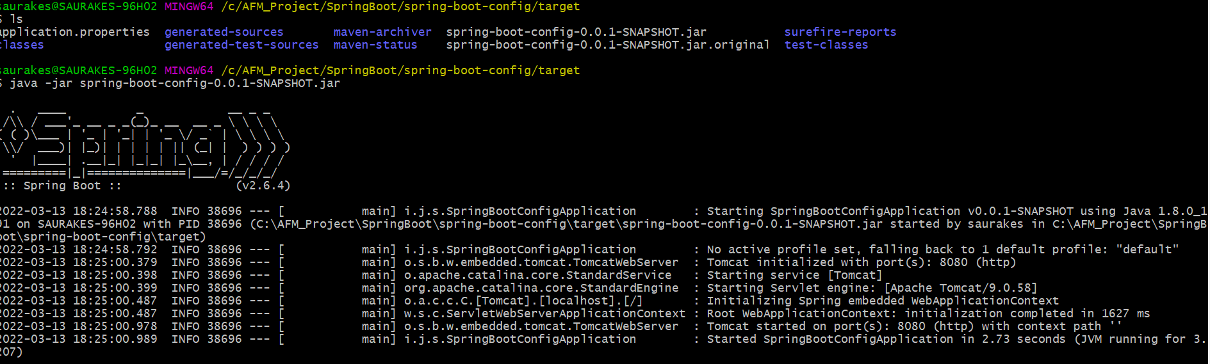)

Spring will overwrite application.properties file if it is found at same level of jar



**NOTE : properties file outside the jar will overwrite properties file inside the jar**

**Note: we can overwrite properties file value from command line argument**

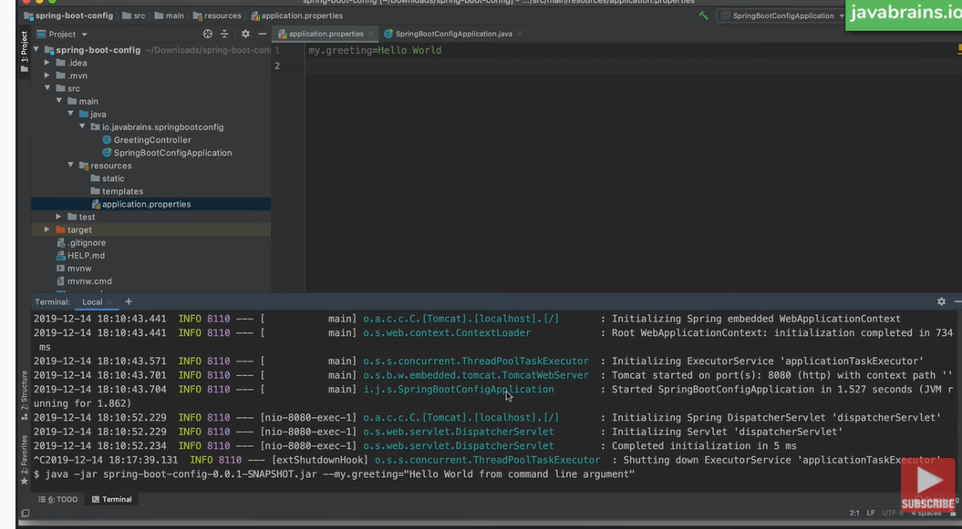

**Cmd line arg priority > priority of application.properties at jar level > properties file inside app**

**Three value annotation tricks**



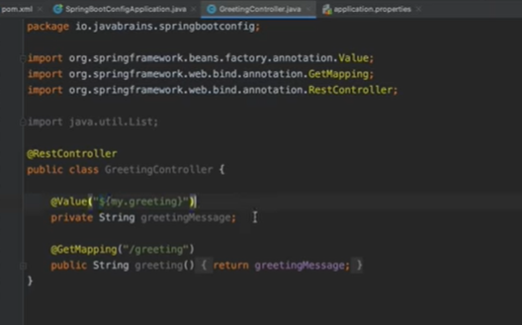

**Note : this is one way of getting properties**

**Dollar curly braces then properties**

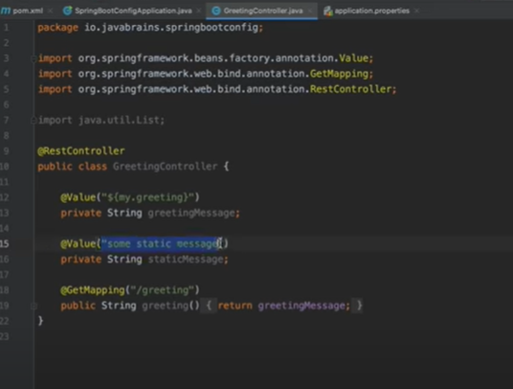

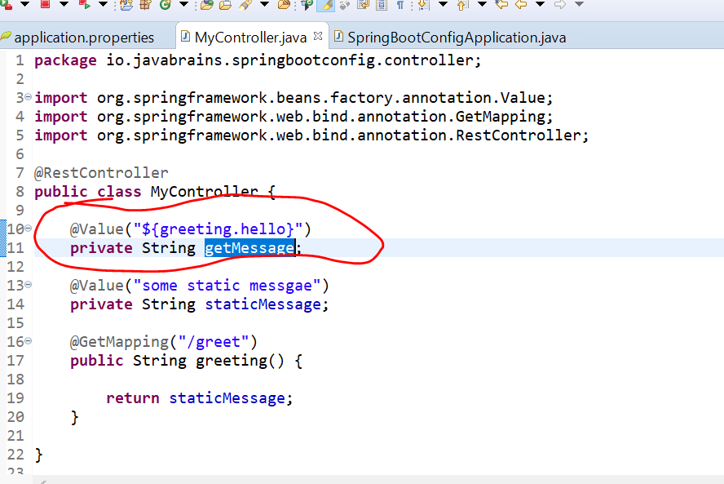

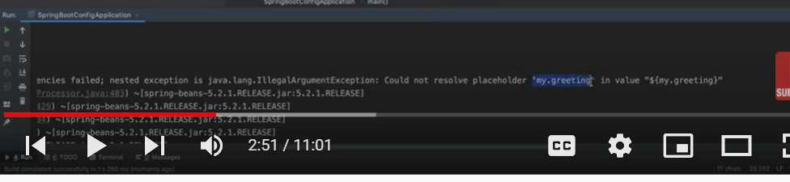

**Note**

if greeting.hello is not present in properties file will get a error.

Since this is literally treated as bean is not available.

Spring container failed because it is not able to resolve the dependency

**NOTE:** what if we don’t want to happen, want to provide default value

We can provide default value

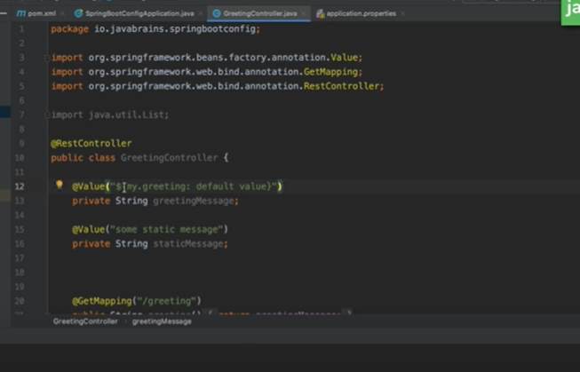

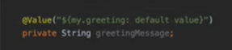

**Note :** if the property does not exist what value need to take

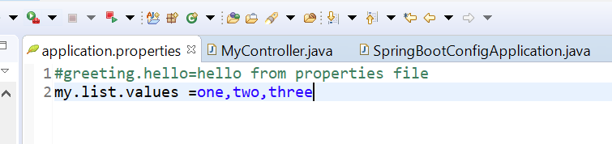

List of value which is comma separated and we want to use this list of value in code

=============================

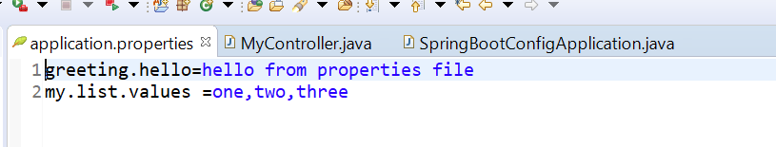

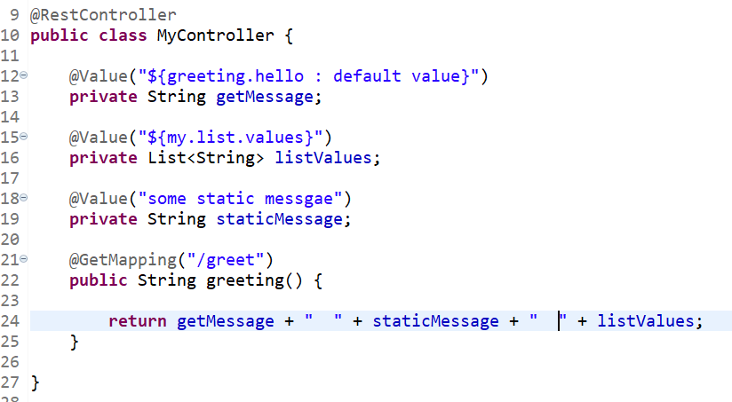

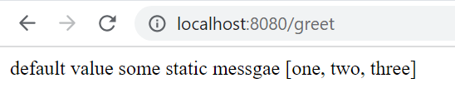

NOTE : we can also work with key , value in properties file ( it is already in key value form but we can declare nested)

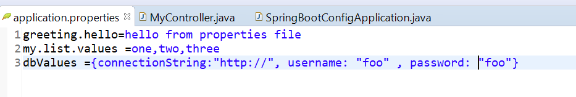

**#----will treat what is there after curly braces and treat as spring expression language---spel**

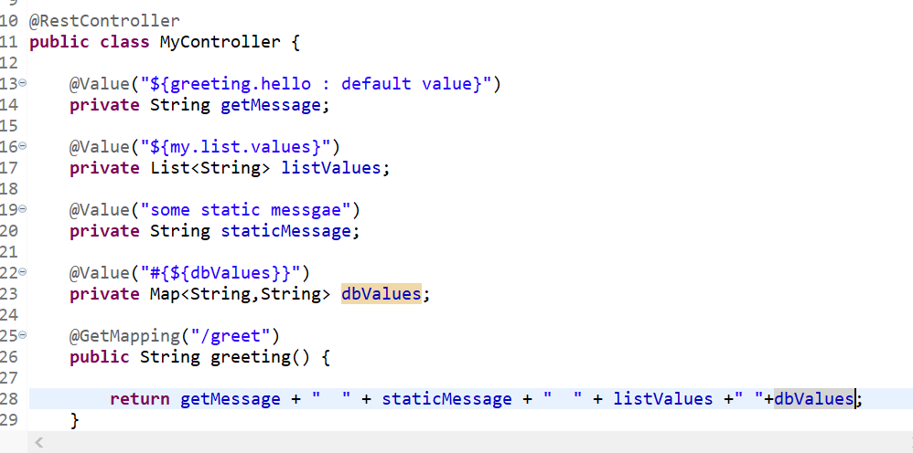

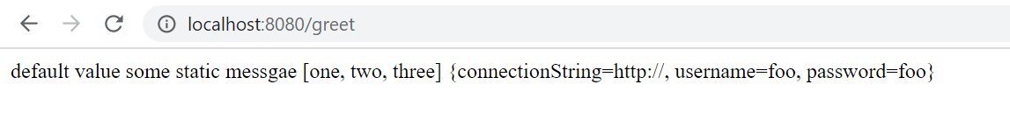

Note : we can use list and map in properties file and we can get it using value annotation in controller class

**@value annotation**

**Providing default value**

**Providing list**

**Providing map**



**Note :**

this is specially use when we have group of configuration and want to pull it at once

This is more powerful to pull up value from properties file

Rather then define @value annotation one by one will define a bean and that bean will be populated with all value

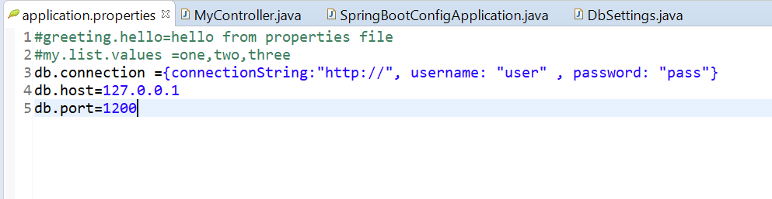

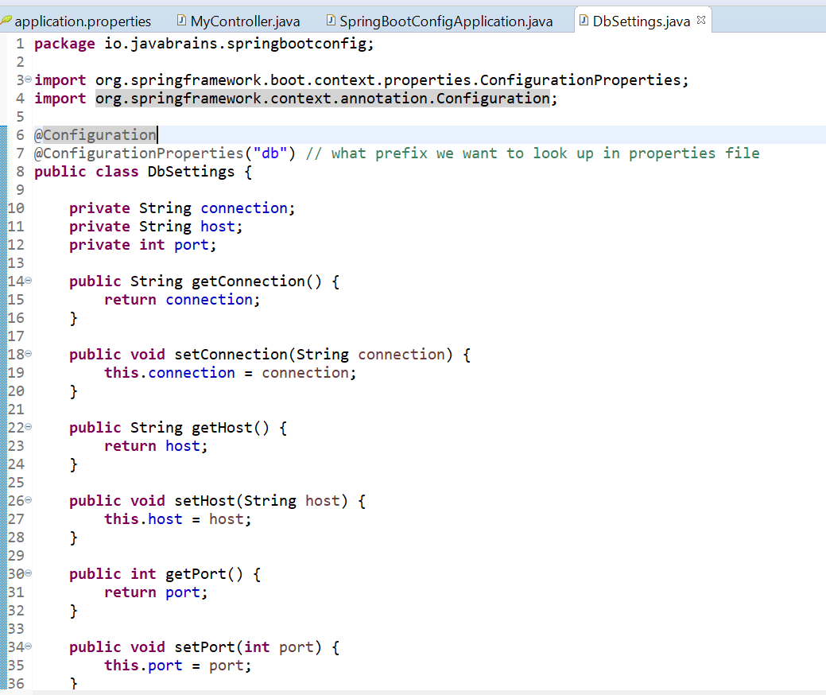

It will inject value to these member variable automatically

@Configuration : spring know to create it bean

**NOTE: now in spring controller will get all at one shot**

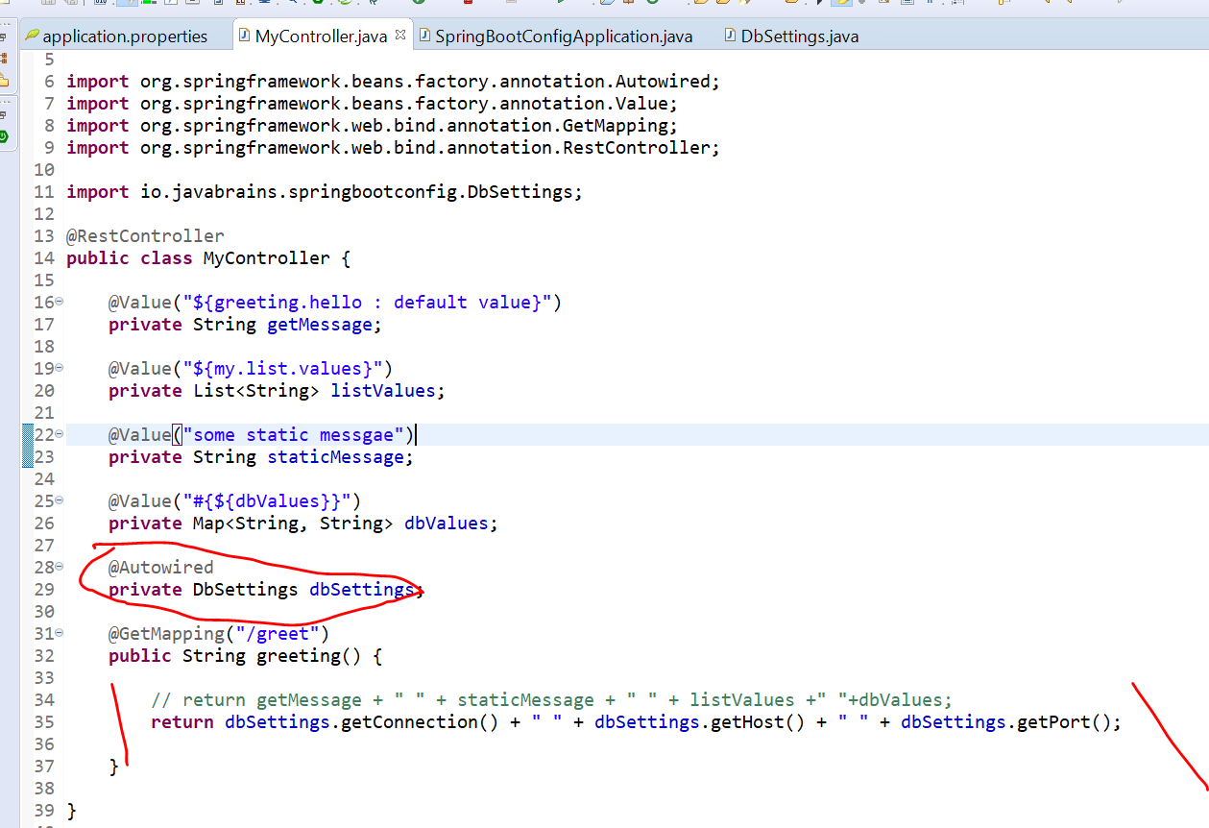

**Output :-**

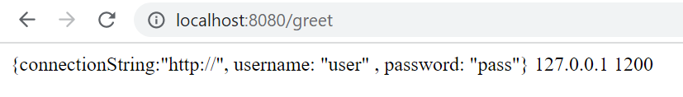

**Question : when to use @Value and @ConfigurationProperties**

**Note : the benefits of using @ConfigurationProperties over values**

1-we can group together all the value

1. Suppose if we want to use in multiple classes like d/b connection then we have bean which we can use it in multiple classes

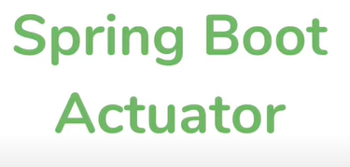

It exposes end point in spring boot application.

It exposes rest end point where we get all configuration either set by us or spring boot application

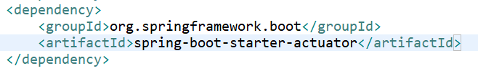

**Note :-**  spring boot actuator does not expose all end point by default

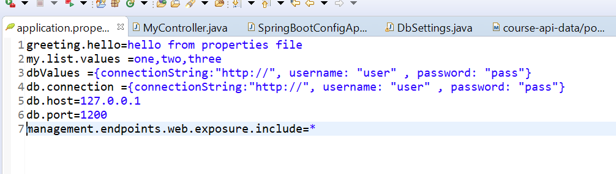

**Means : want to expose all endpoint ----in production we don’t need to use this**

management.endpoints.web.exposure.include. **info, health**. The include property lists the IDs of the endpoints that are exposed. The exclude property lists the IDs of the endpoints that should not be exposed. The exclude property takes precedence over the include property.

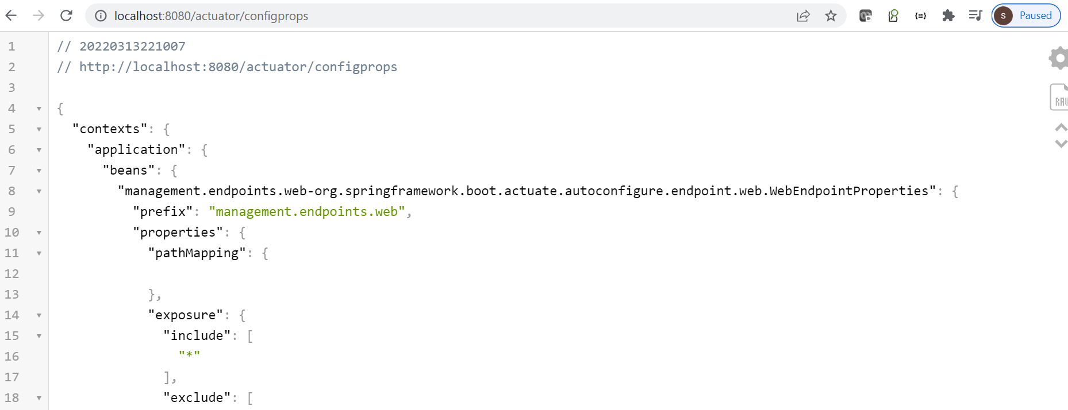

<http://localhost:8080/actuator/configprops>

This will show all the configuration . It will also show what the value currently set

====================================================================

Using yaml file MS configuration

Better approach compare to properties file

Yaml : used to **yet another markup language** but they change it **yaml ain't markup language**

* It basically a language to store data element
* Yaml has syntax of key:value
* = replace with : space

**Note : we can remove repetition in yaml**

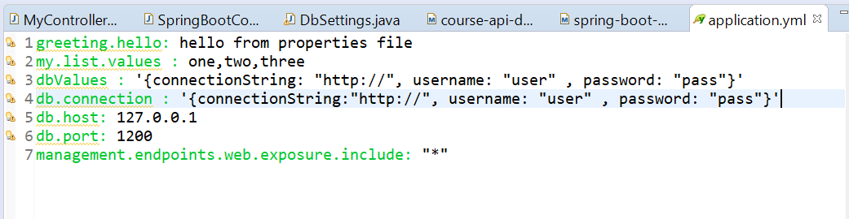

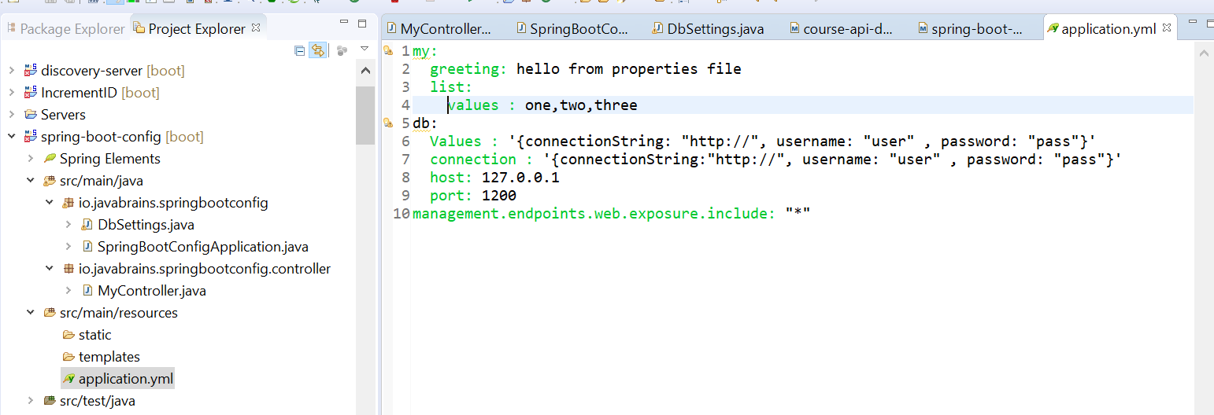

This will exactly work same as properties file

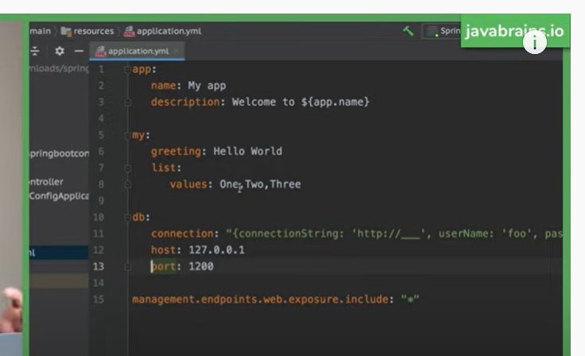

Understanding Spring Profiles

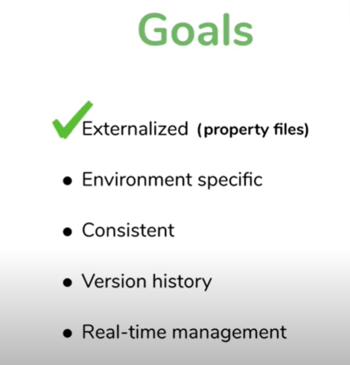

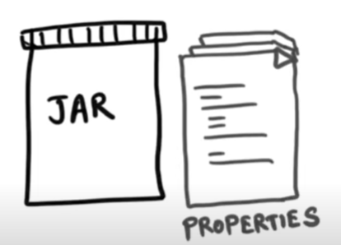

We need to put properties file same location as jar

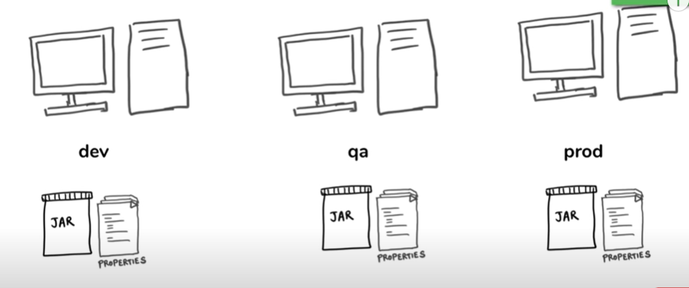

**Technically we can do it , we have different properties file for diff env**

**Note :** but this is not good wt the drawback

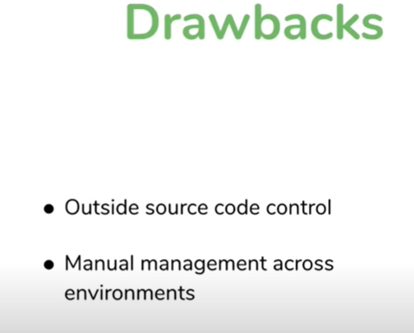

Manual deployment to change the properties file. This is not ideal

Now how we will solve this problem **using spring profiles**



In order to have diff value configuration in diff env

**A profile as a pre set of configuration values go together and group and form a profile**

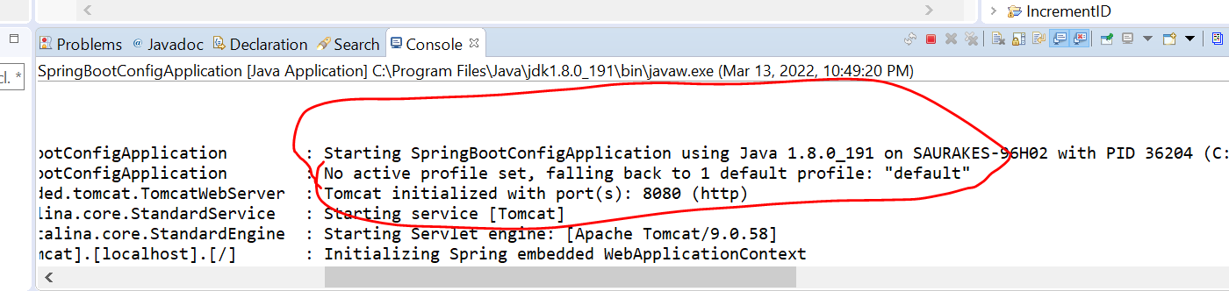

**By defualt-----**default profile is active.

We can create multiple other profile

**Naming convention for creating new profile**



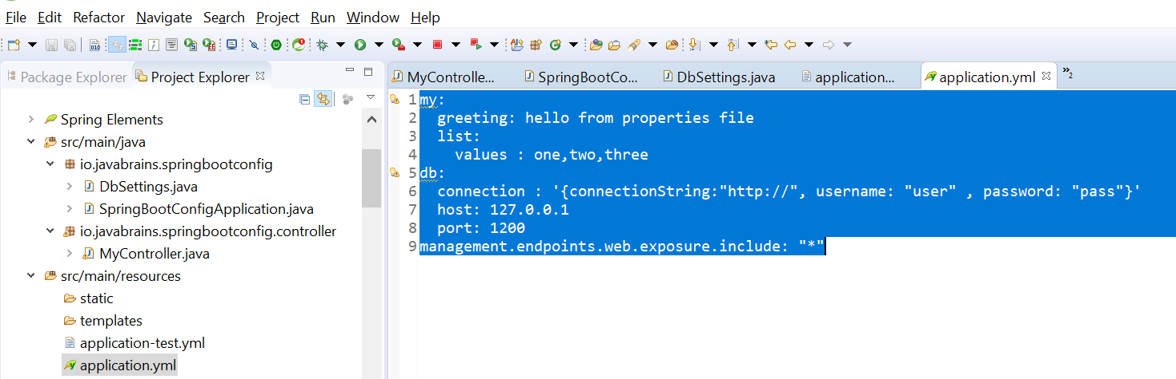

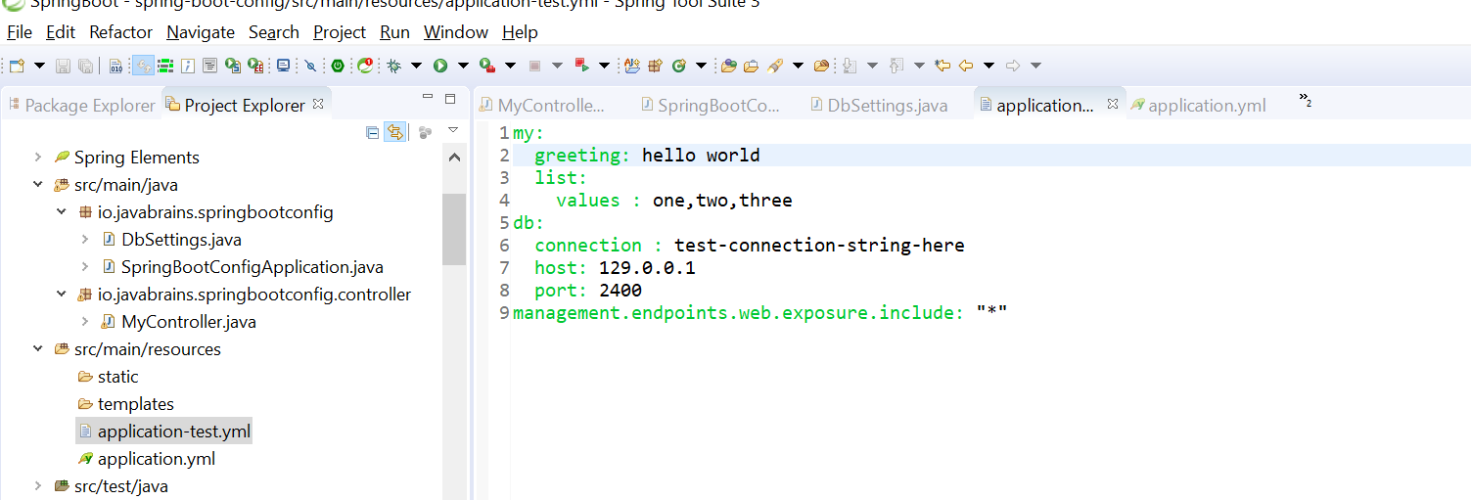

**Imp point:----**

**Now if restart the application nothing changes because default profile is active by default**

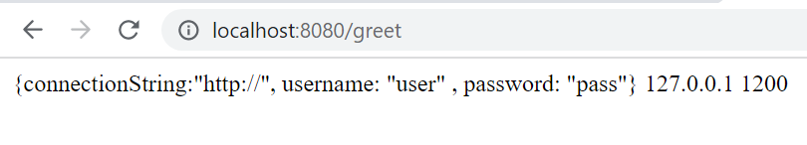

**Now :--- I need to tell spring , I have a different profile when running application u need to consider a different profile.**

**How to do that**

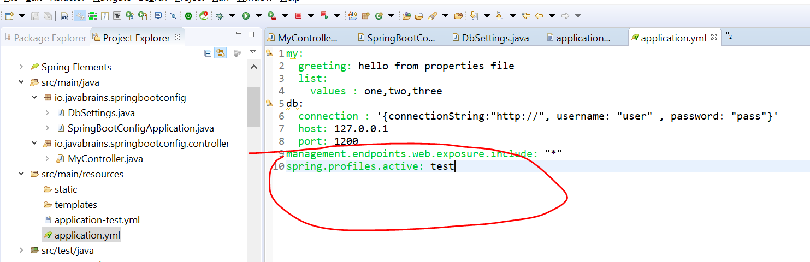

**By configuring spring.profiles.active: test in application.yml which is default profile**

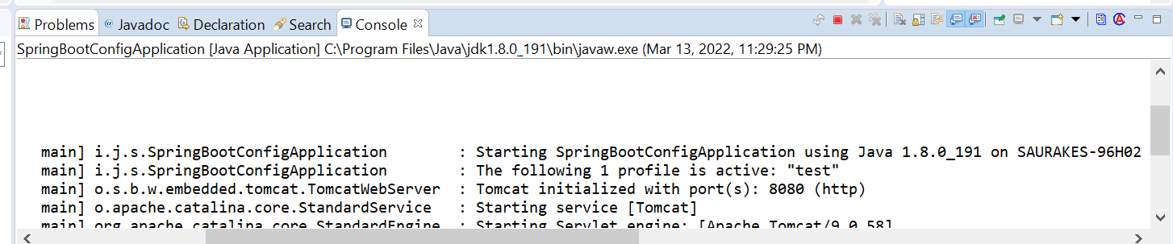

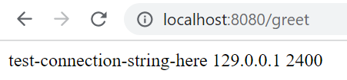



**Note : wts happening here default profile is always active---application.yml is always active.**

At any point of time two profile will be active one is default profile



**Imp** If something in there default profile (keys) which is not in test file then still default onw will applies

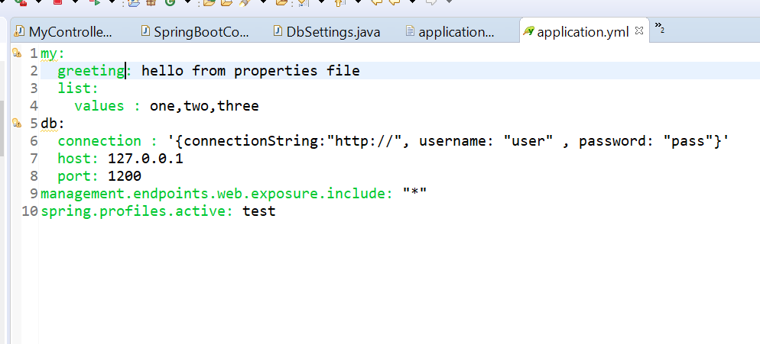

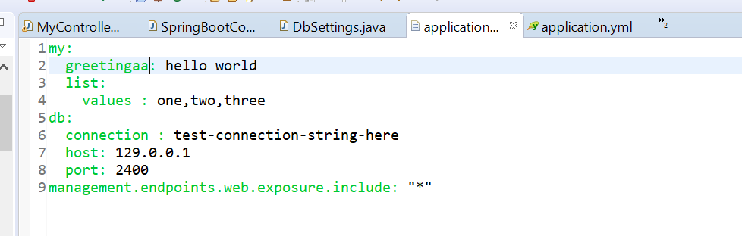

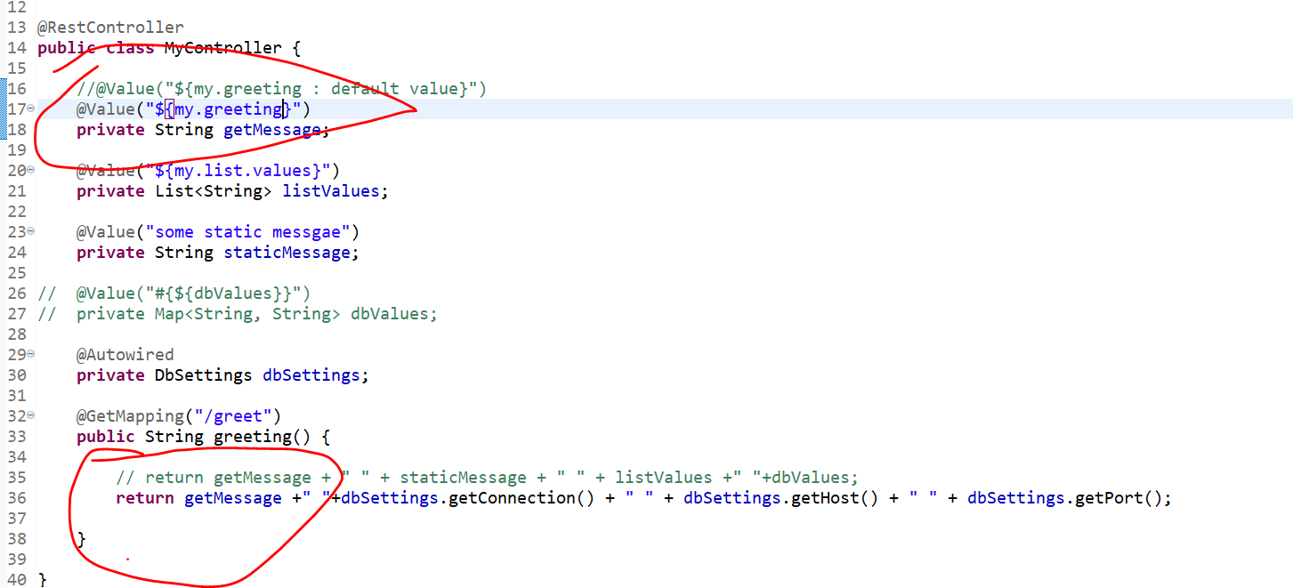

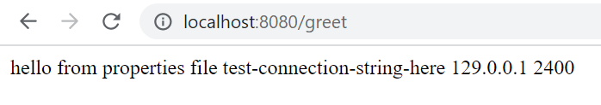

**Note**

**We can have multiple profiles active in default profile but order is matter**

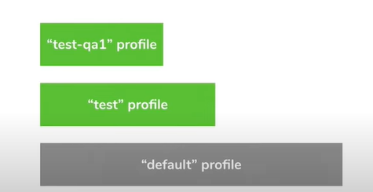

**Now how this is helpful :** we can create different property file for different environment

connectionString will point to dev,qa,prod

**Note:**

**for all common thing we don’t need to put from env to env . We can put in default environment which is applicable for all**

**Query** : have we achieved env specific deployment without modifying profile

**Ans :** no

**When we are putting active profile is test and that is still setting in jar which is a problem**

**No that is not a problem we can pass command while deploying**

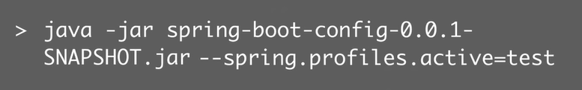

**Now we can have env based configuration without modifying manual jar**



**Important features**

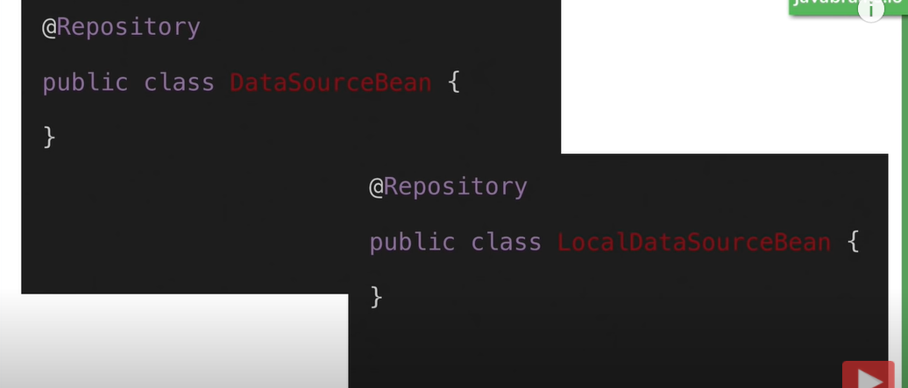

**Note:**

When we running app in prod want DataSourceBean need to run and when local want LocalDataSourceBean need to run

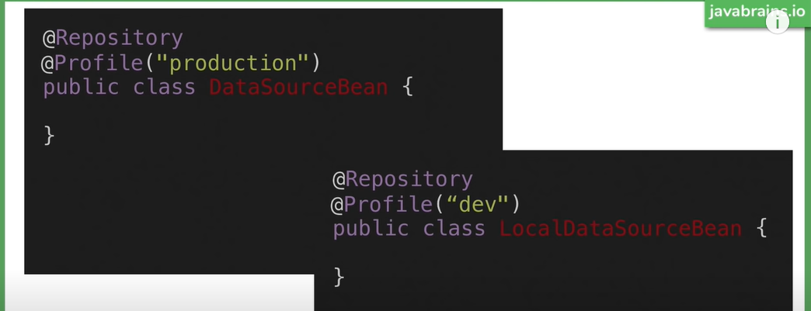

Wn application is running in dev profile spring boot is going to initialized LocalDataSourceBean

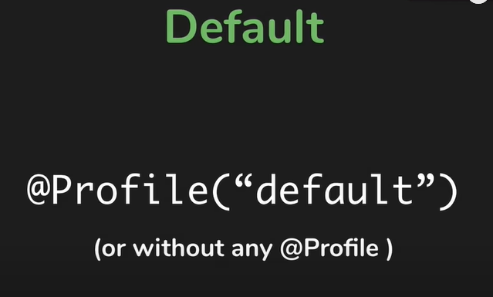

**What is profile in spring?**

What is Spring Profile. Spring Profiles **helps segregating your application configurations, and make them available only in certain environments**. ﻿ An application run on many different environments. For example, Dev, QA, Test, Stage, Production etc.

**What is the default profile in spring boot?**

The default profile is **always active**. Spring Boot loads all properties in application. yml into the default profile. We could rename the configuration file to application-default

Using env object :- MS configuration

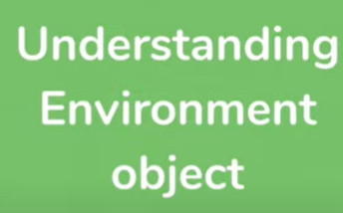

@Value ,@ConfigurationProperties :----it inject the values

It help to look the properties value

**Environment:** is a bean that we can inject, that we can autowired into application into classes and then and access the configuration values using it. We can figure out what active profile is.

**Note: Environment is from spring package**

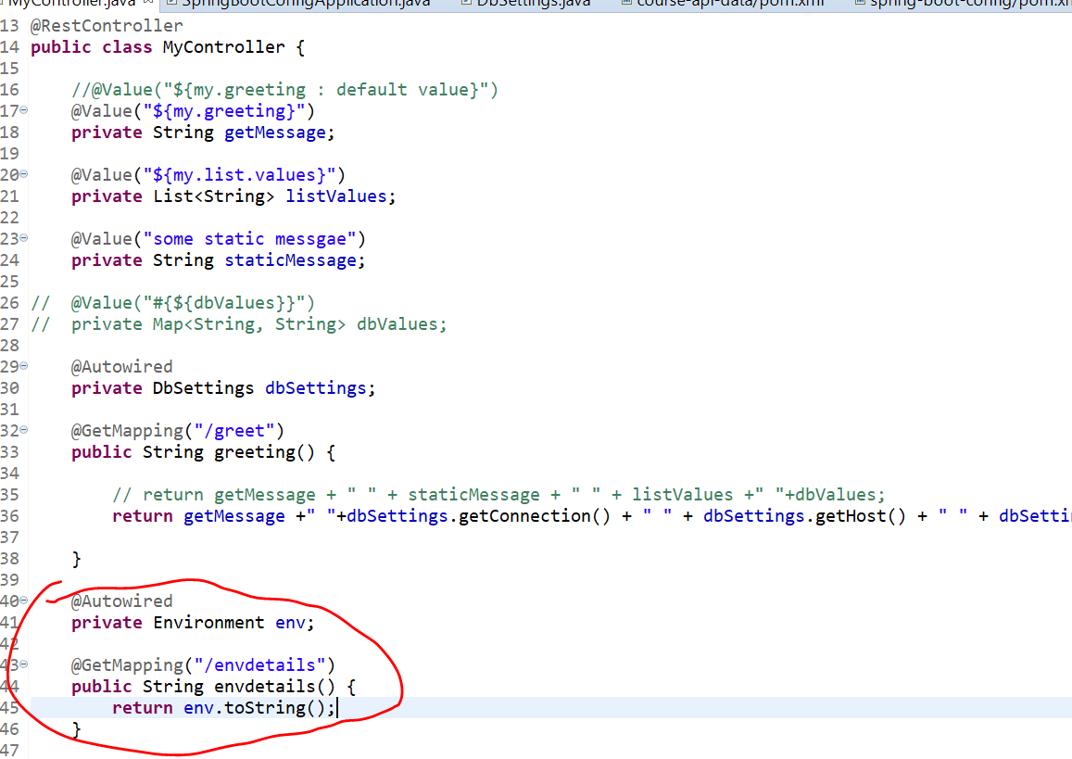

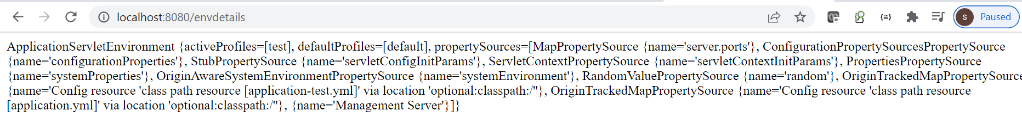

**NOTE:** what spring does by default we can programically access it and set the value

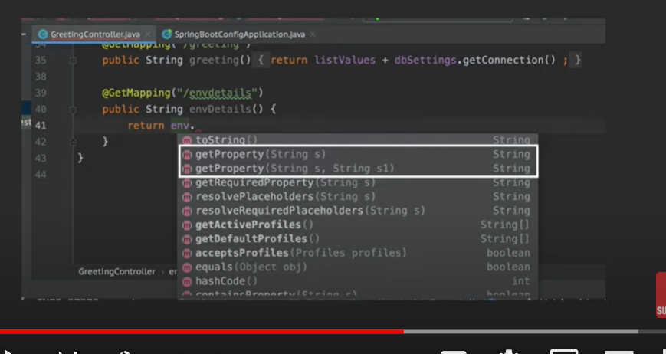

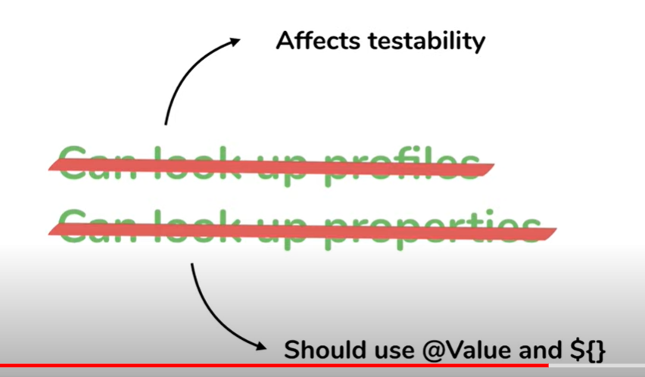

**Note :**

**this is bad we should not look up profiles and we should not look up values also manually**

**What is spring cloud config server**

**Note: upto here configuration is great for single application**



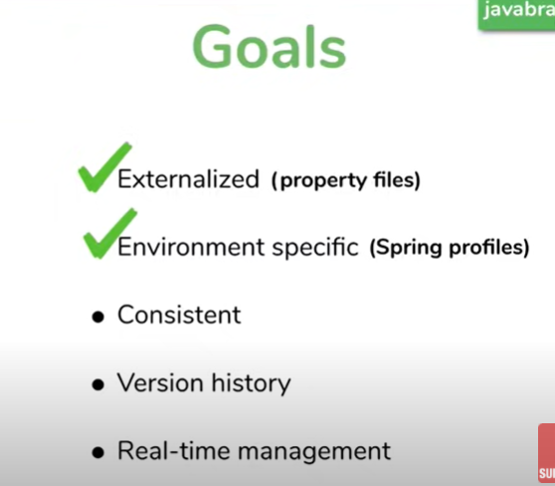

**How to achieve consistent ?**



**Imp point : we need to make sure in case of MS they are referring same configuration value.**

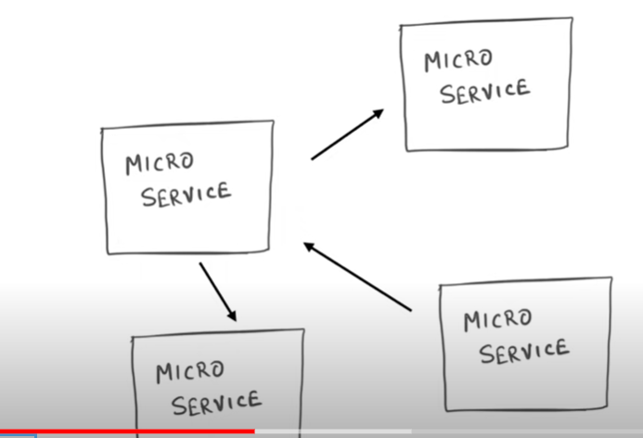

**We cannot really do for each MS------configure a configuration then how to do this**

**Ans:---- take it out and create a separate configuration service**

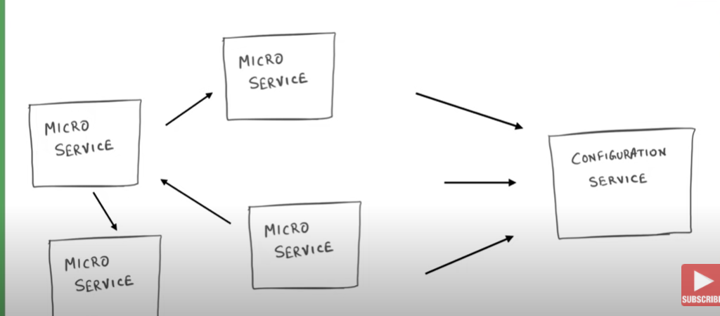



**There is one source which provide info to all MS. When it will ask that a separate thing**

**What is Apache ZooKeeper used for?**

ZooKeeper is an open source Apache project that provides a centralized service for providing configuration information, naming, synchronization and group services over large clusters in distributed systems. The goal is to make these systems easier to manage with improved, more reliable propagation of changes.

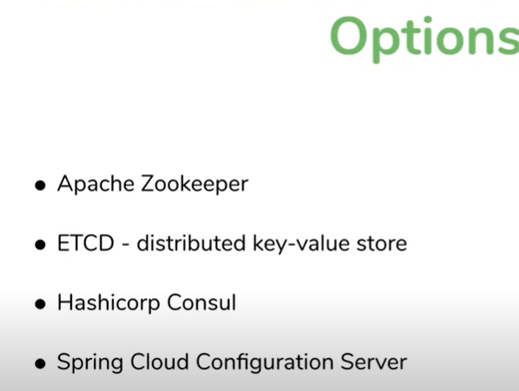

**4th one is more popular specially in context of spring cloud configuration server**

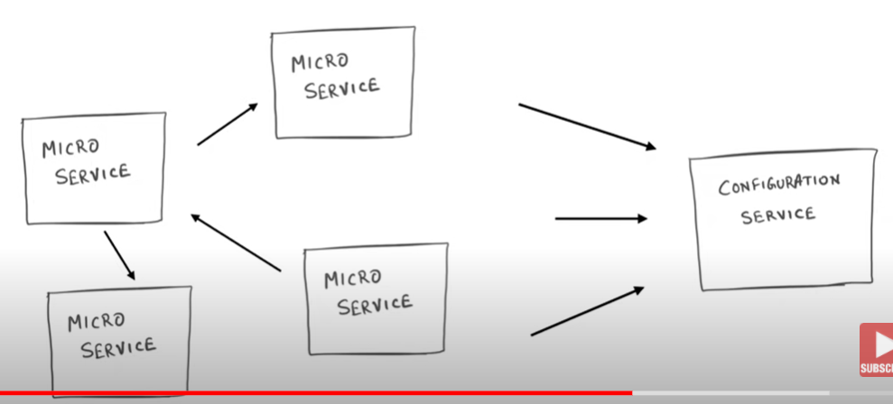

**Note : if we will use config in source code then we need to redeploy if any config change**

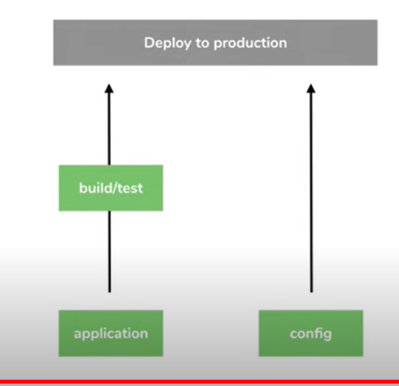

**Note : we want to change in config without redploy.**

**All different MS talk to spring cloud config server which sit at center**

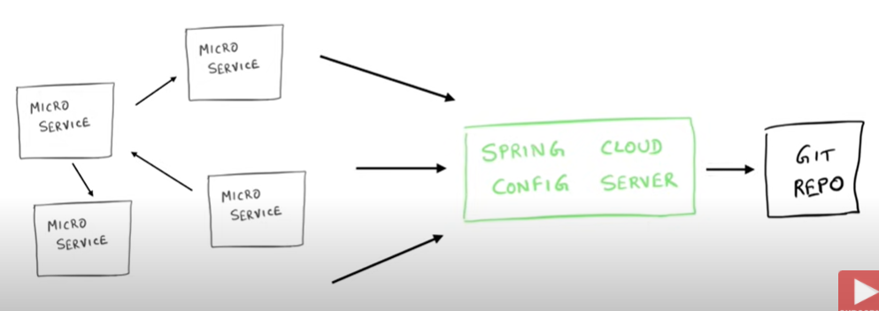

**Spring cloud config server directly lookup git repo which is hoisted somewhere.**

**It directly lookup the value of properties in files in github which is online**

**Setting up spring cloud config server from scratch**

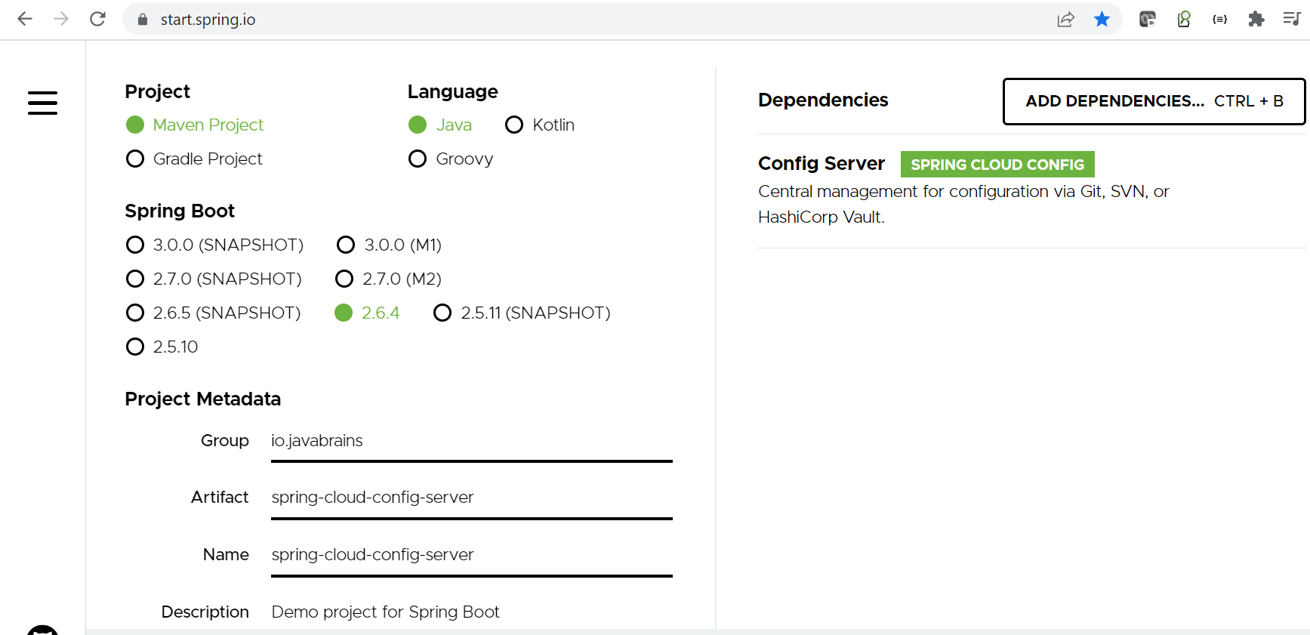

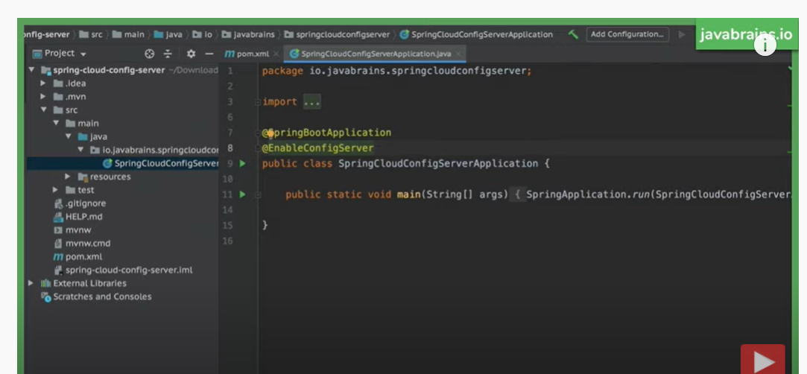

**Add @EnableConfigServer**

Now config server good to go but it doesn't know from where to lookup the value

Ans :- we can take value from git

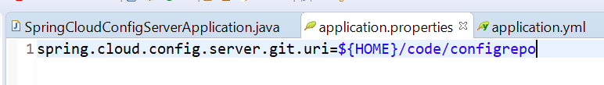

System properites for home location :---- under this path application.yml file is there

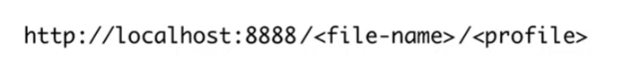

Profile is default

File name is application

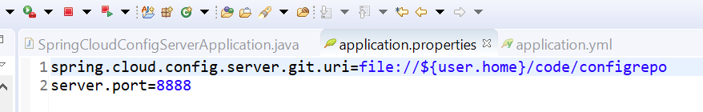

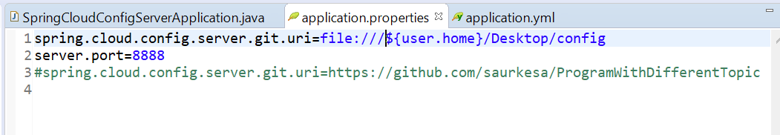

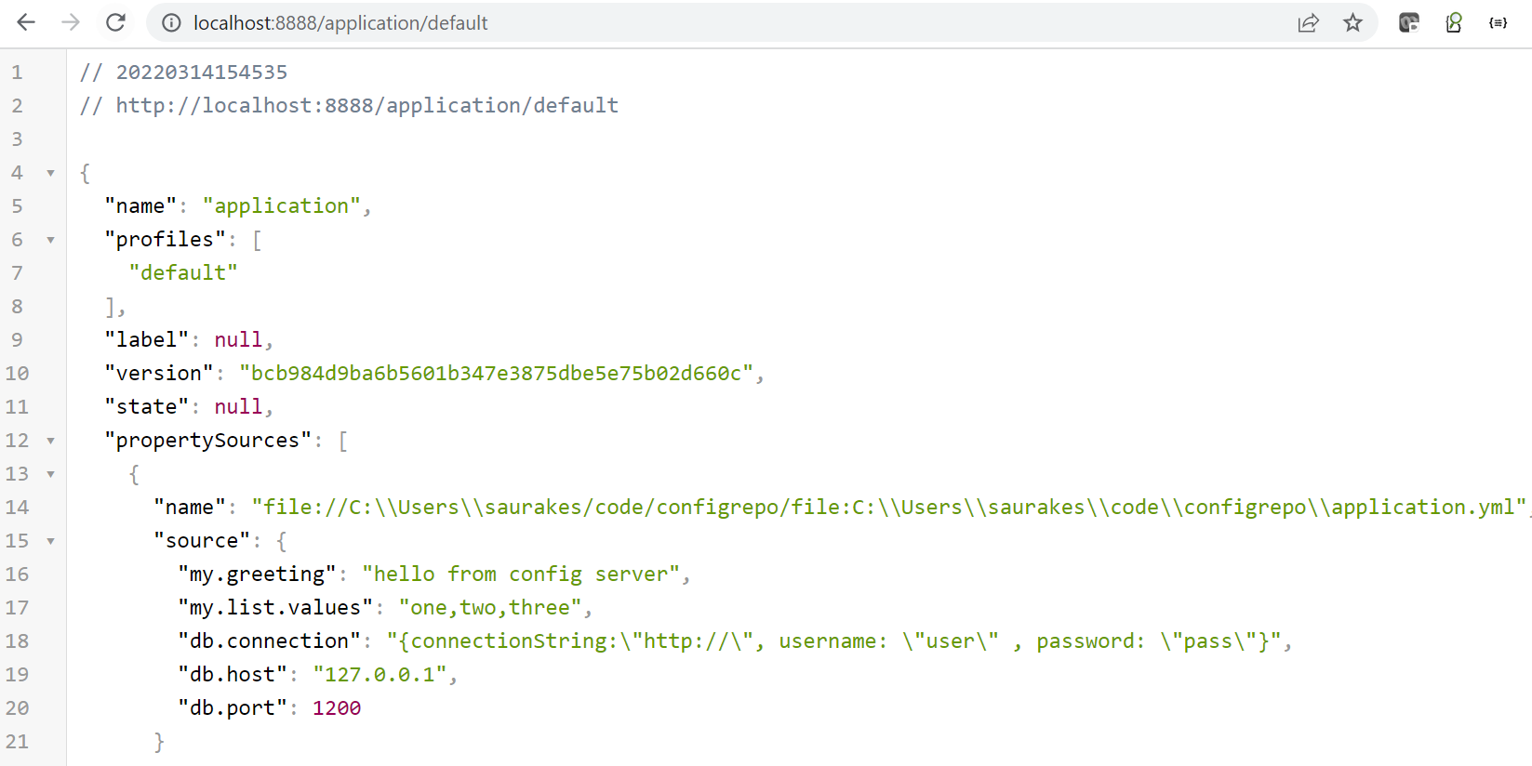

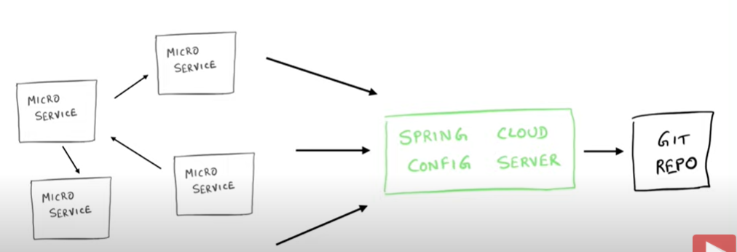

Now all MS will talk to spring cloud config server

**Setting up spring cloud config client MS**

**Requirement :-- MS get the configuration from spring cloud config server**

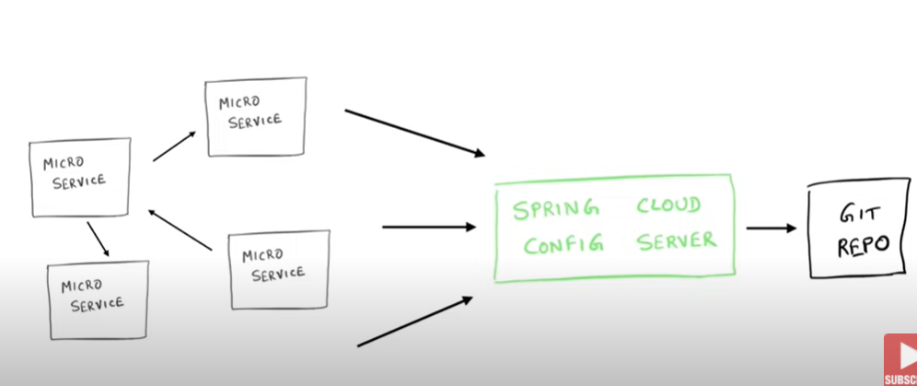

**How to consume application.yml file by MS**

**Step 1---- add the dependency**

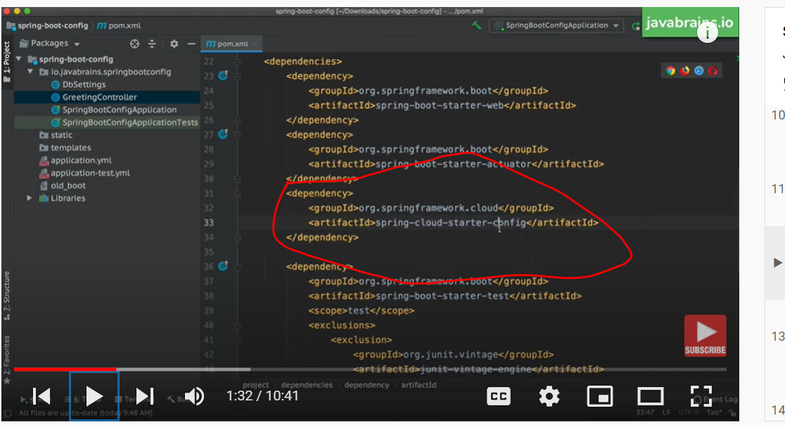

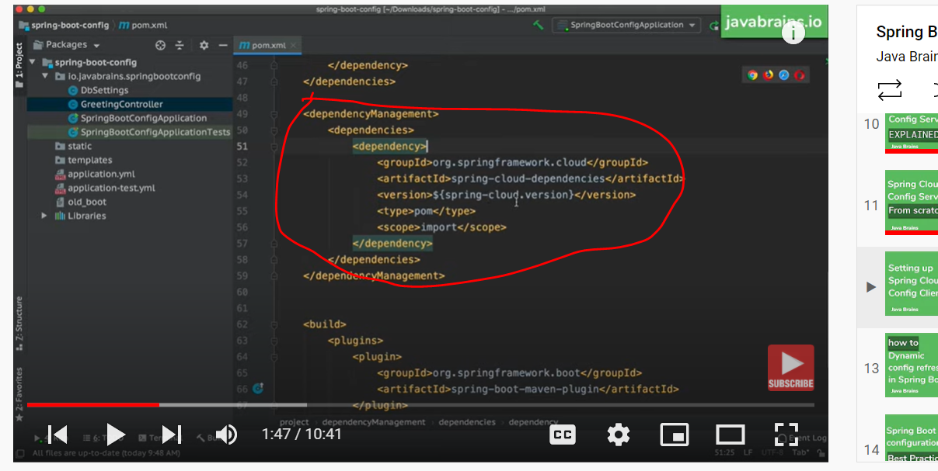

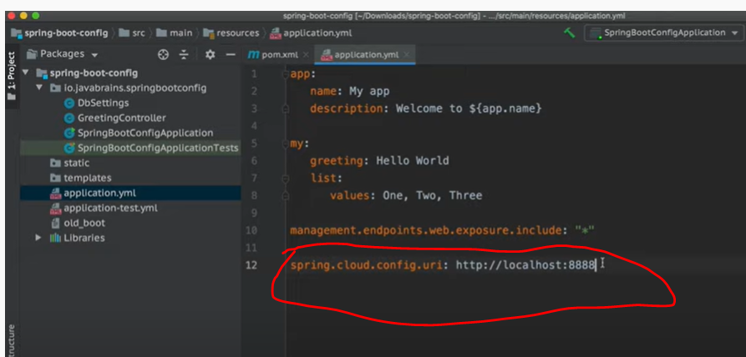

**We need to add this line in application.yml in MS**

spring.cloud.config.uri: <http://localhost:8888> -----which points where our application server is running

Config server will connect to git and MS will fetch configuration from application.yml which is commit to github and config server point it

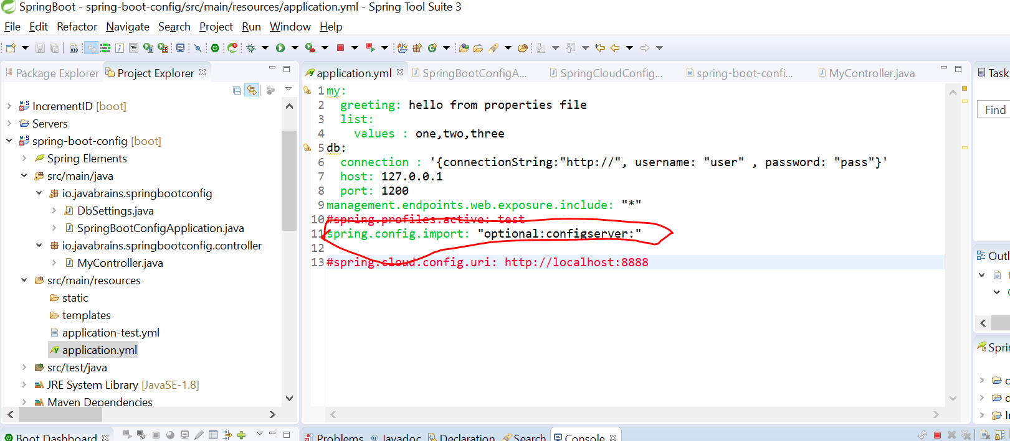

**Note : here the values coming form config server**

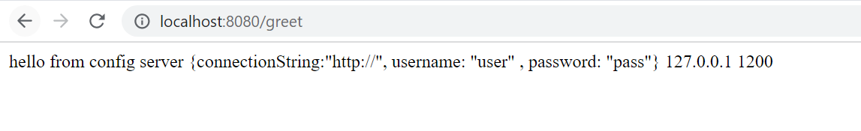

So if we have 10 MS. All MS can connect to config server and pull the values

**Query : what if we want to configure something which is MS specific**

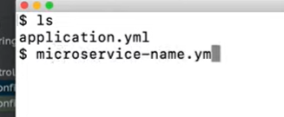

**We need to put this file in github and only if particular MS is requested then spring will response to it**

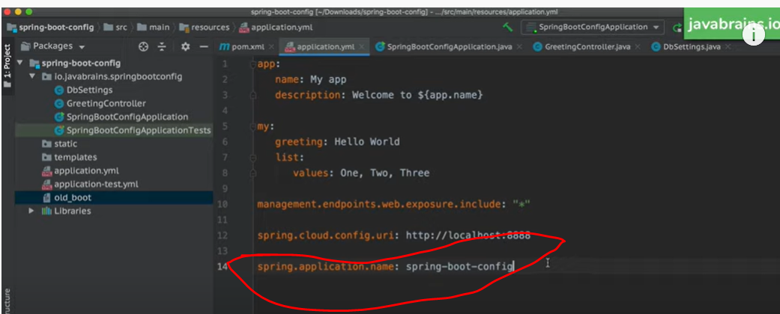

**This application name tied to file name present in github**

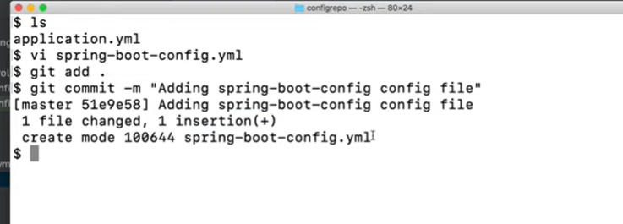

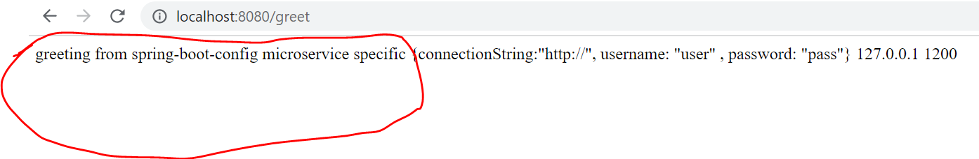

**Imp :- This info we are getting from MS specific yaml present deployed in github having same name as MS**

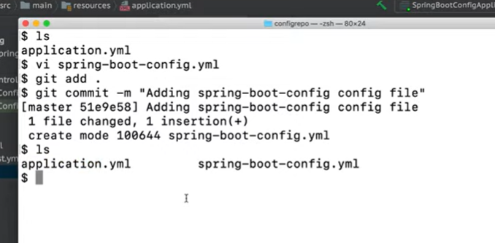

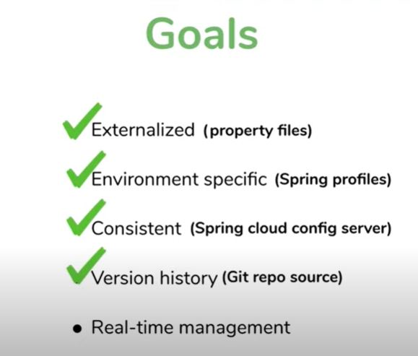

Version history also we achieved using git

**Dynamic Config with spring boot MS**

**Refreshing properties or config at real time without even stop MS**

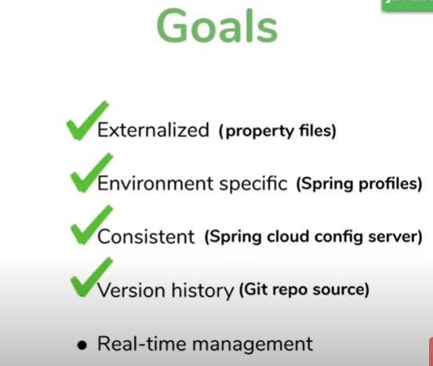

**Suppose we update config file in github and how MS will get update without restarting MS**

**Note :**

If we change in config fileand push in github using server config and MS which is already started then changes will be reflect in MS also

**Config server**

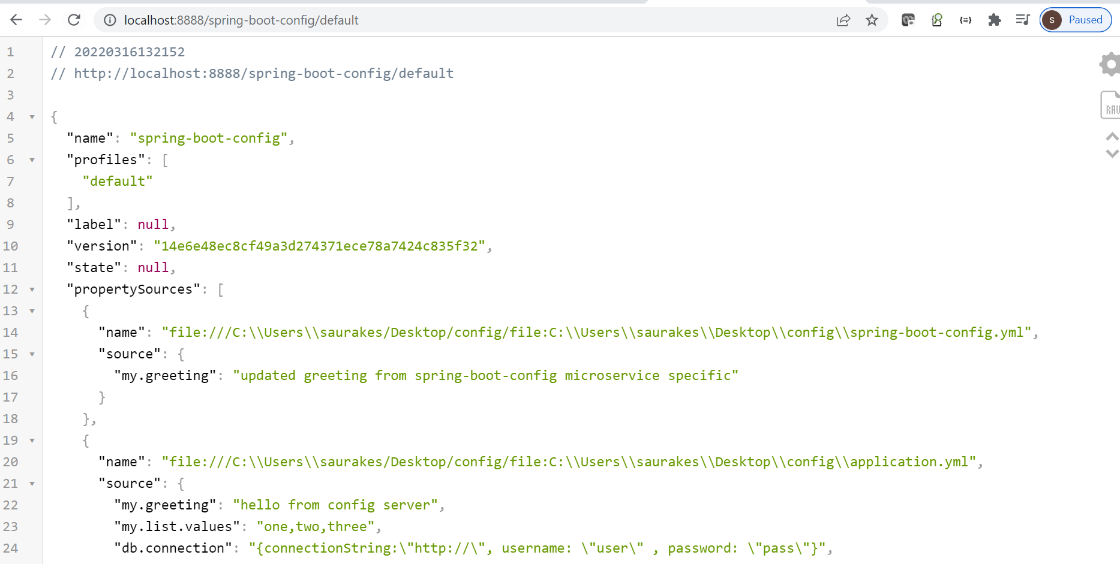

**Note :--- But client doesn't get updated value why this is happening**

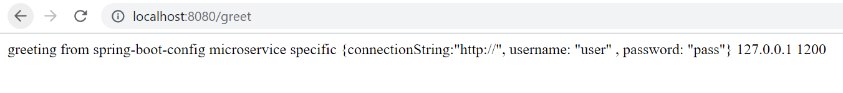

**Reason :-** this is happening because the server is always looking git repo for update for every request so we don’t need to start spring cloud config server when there is a change in git repo that contains the properties file

**Note :**

The challenge in getting the client to be updated how this will be update

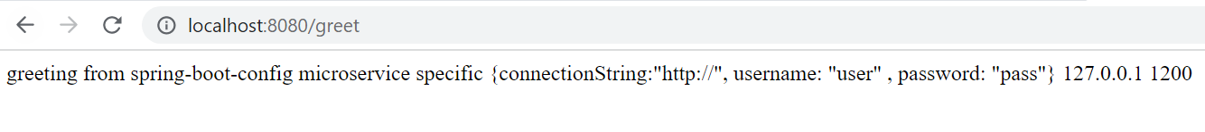

**The only way to get this updated by restarting the server**

**Query :----- is there any way to update this without restarting the server**

Well there are couple of step need to do it

**Step 1: actuator should be there**

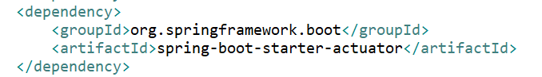

Note : all endpoints will be exposed by this properties



Note : one of the end point that spring boot actuator exposes is a hook for u to call to tell the application to refresh it

**Actuator:**--- when application start it will call hook which take all the update config

**Step 2:-**

It will only refresh that bean which is marked by annotation **@RefreshScope**

**This tell spring boot whatever the configuration used here that need to be refresh**

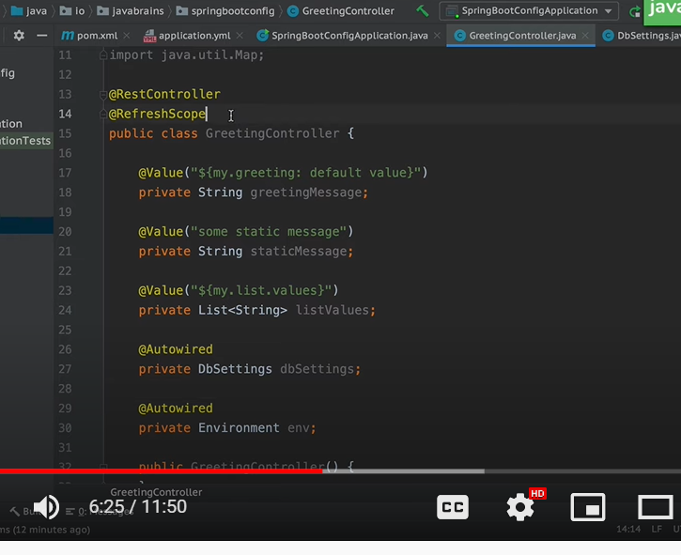

**@value --dependecy injection**

**All the dependency of this bean need to be refresh and the dependency here is config value**

**There are two for MS to be refresh**

1. Actuator :- which will called end point
2. @RefreshScope : which tell all the dependencies need to be refreshed

**So below are the end points when we want refresh to be happen**

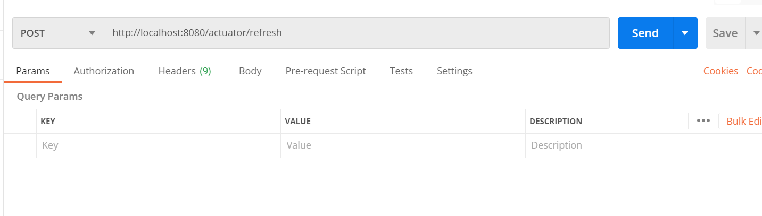

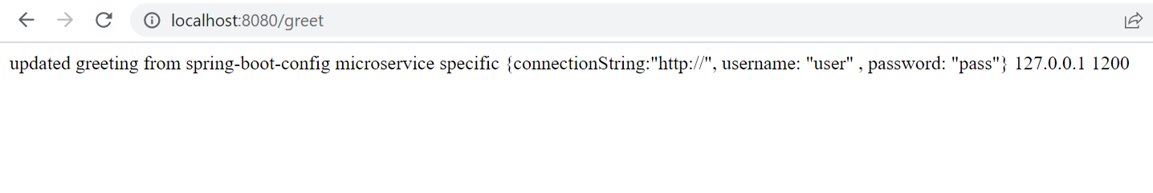

**So this is updated**

**Note after using @RefreshScope and actuator we are not going to restart the server once we change application.yml file and commit in github which is monitoring by spring cloud config server**



**Client doesn’t know need to update**



**The way to do it we need to make post call**

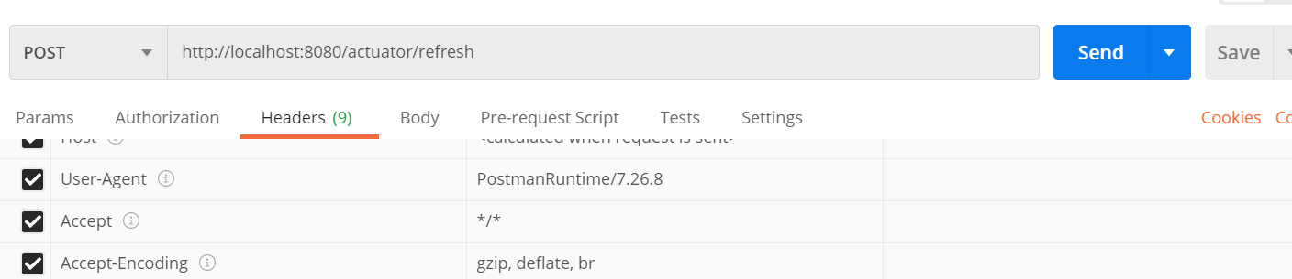

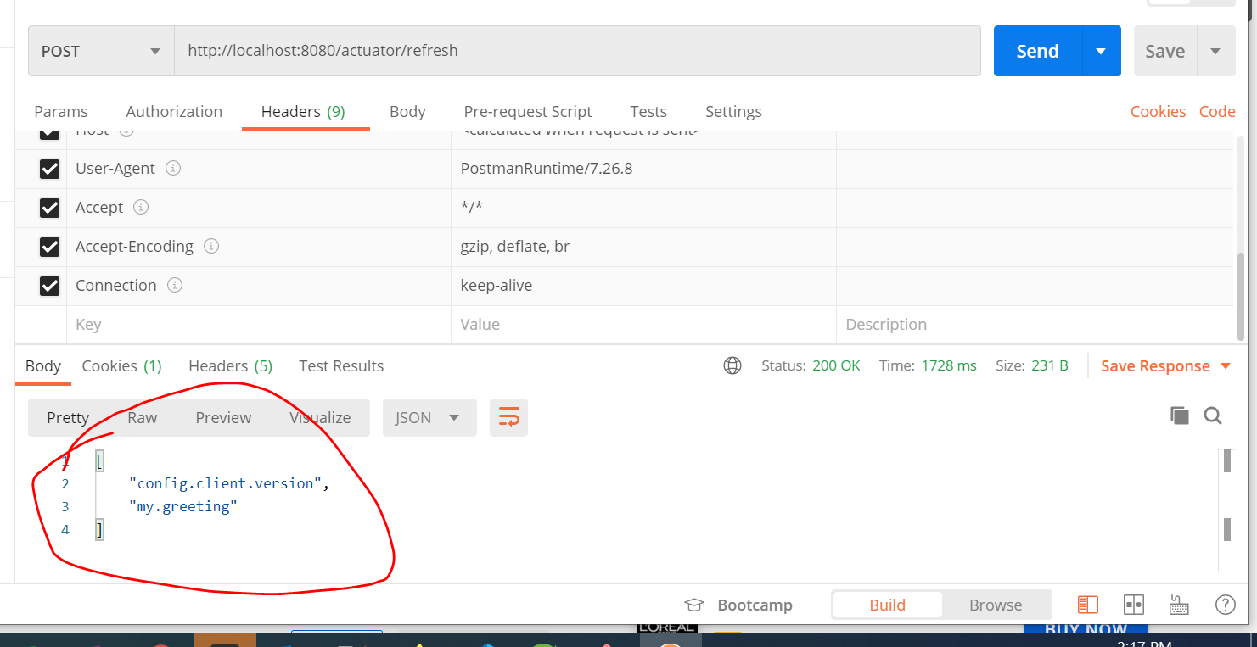

**It showing the response :- my.greeting** changes and **config.client.version** got changed

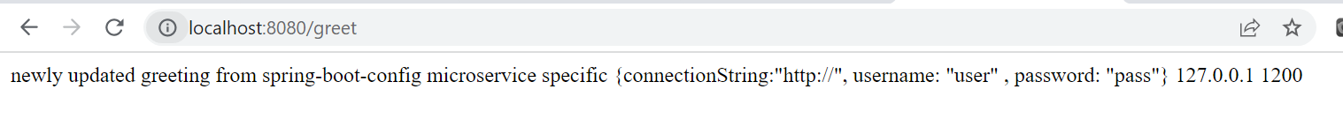

Now the MS got updated

Microservice Configuration best Practice

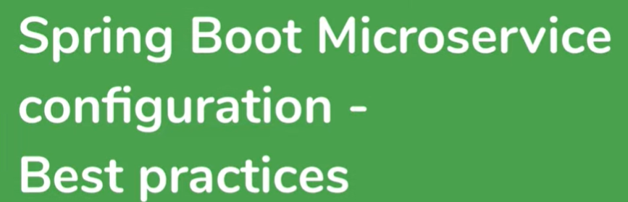

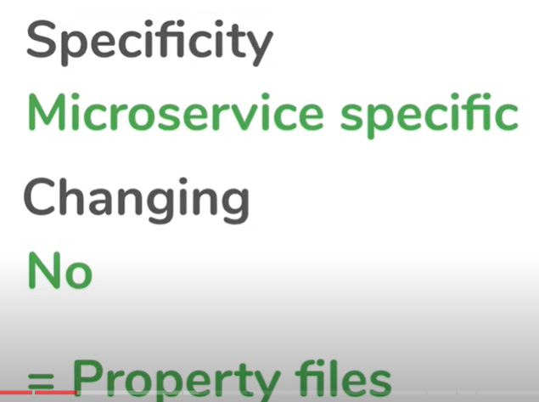

Changing is to MS specific

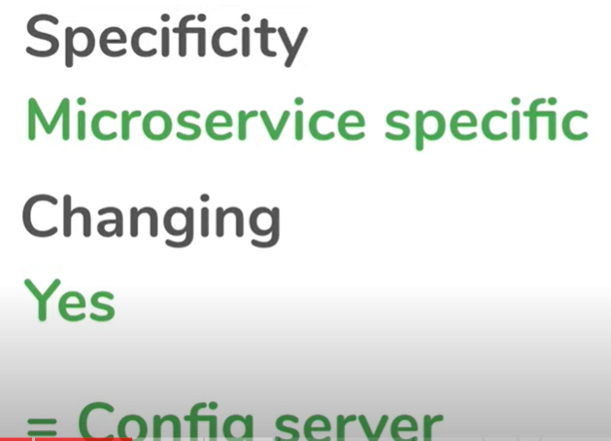

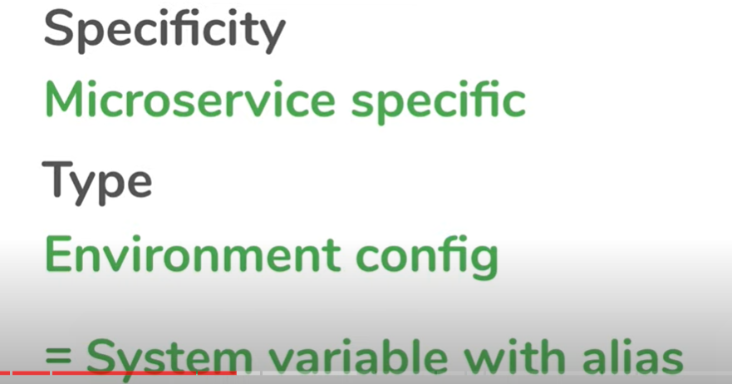

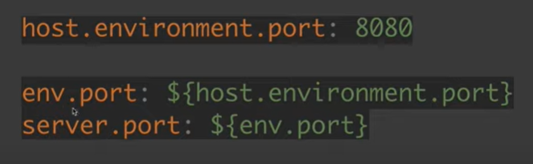

Recommendation is to use something like this : that will be change like in aws and azure

1. It readible and consistent across diff environment





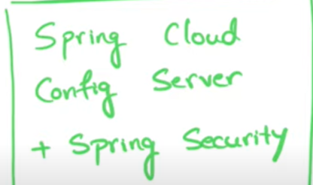



Use encryption for secure configuration which will get from git into spring cloud config server.

**Note: we don’t want to save these value in plain text file**

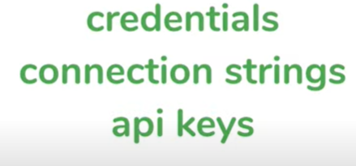

In github :--

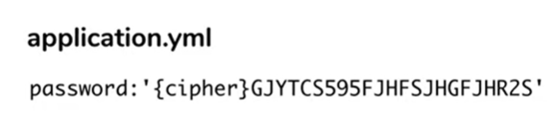

Note : spring cloud server has the ability to encrpyt and decrypyt value.

When it will get fromgithub as decrypt value. It will encrypt it and when some MS will call it then spring cloud config server will return decrypt value.

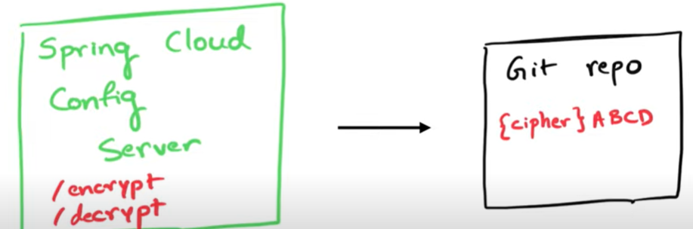

Note : **the data in git repo is in encrypted form**

**Spring cloud config server need JCE which is responsible for encrypting and decrypting**



